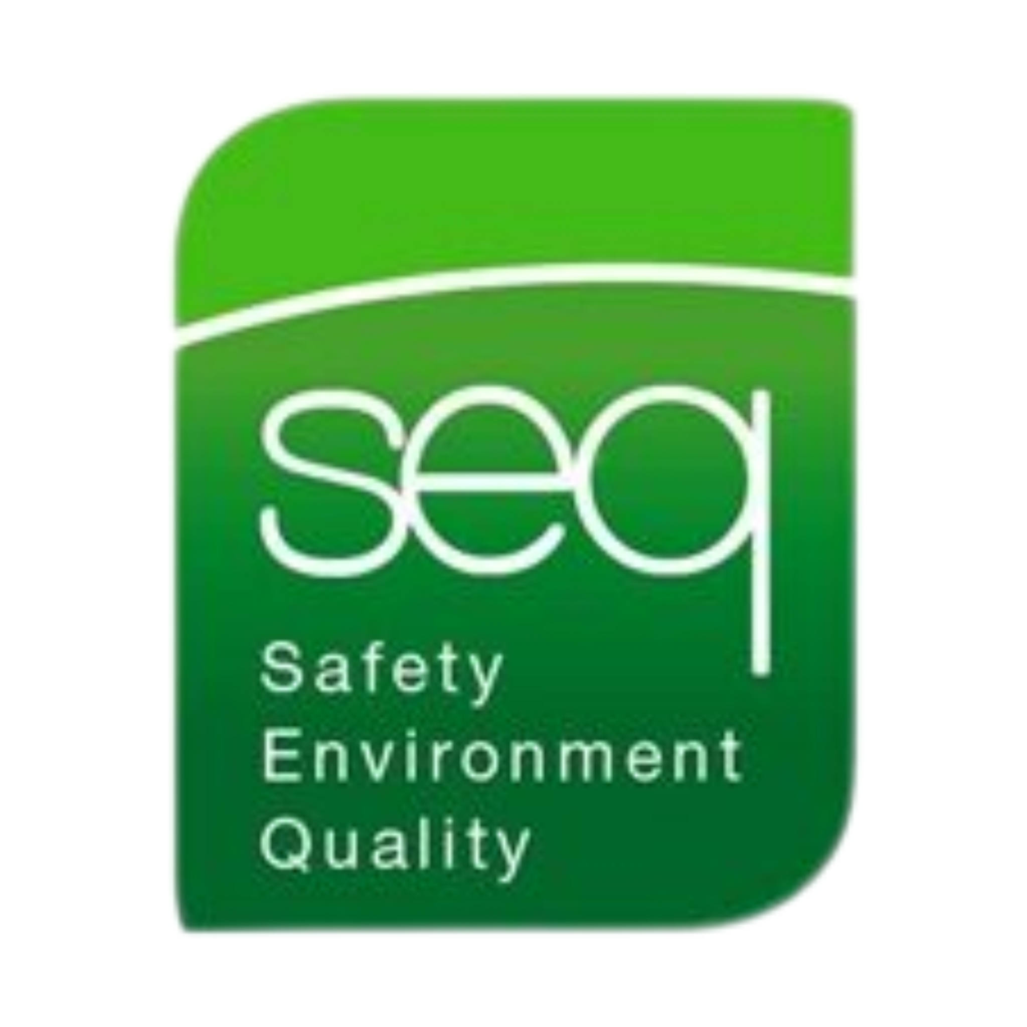 |  | Abrasive Wheels Training
Health & Safety Training to protect employees and your business.  Contact  PHONE:  01 835 1454  EMAIL:  fergus@seq.ie  WEB:  www.seq.ie  Address:  Unit 11A, Block 4 Ashbourne Business Park Ashbourne Co Meath  A84 W290 |  | Course details  This is a half-day course designed to provide the course participants with the appropriate knowledge of the hazards and dangers of working with Abrasive Wheels.  - Awareness of hazards & dangers of working with Abrasive Wheels  - Provides the expertise required for mounting, setting and using Abrasive Wheels.  - Importance of PPE and how to use it correctly  - Safety Regulations pertaining to the use of Abrasive Wheels - The Safety, Health & Welfare at Work (General Applications), Regulations 2016  - Guarding of the grinding / cutting machines and the importance of good housekeeping in the working area  - Dressing and turning  Requirements  Each candidate must have a good knowledge of both written and spoken English.  Details  Duration 3 Hours approximately  Number of Participants Maximum 10  Certificate Renewal Every 3 Years

