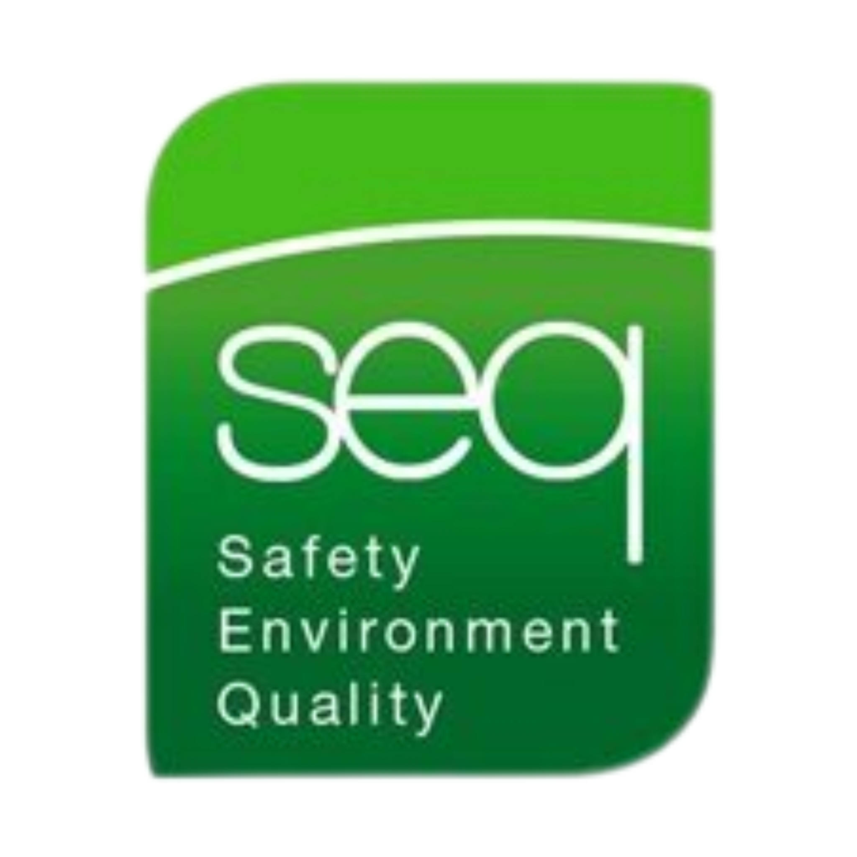 |  | basic first Aid Training
Health & Safety Training to protect  employees and your business.  Contact  PHONE:  01 835 1454  EMAIL:  fergus@seq.ie  WEB:  www.seq.ie  Address:  Unit 11A, Block 4 Ashbourne Business Park Ashbourne Co Meath  Ashbourne Co Meath  A84 W290 |  | Course DETAILS  This one day course educates participants in the proper response to any first aid emergency. This course is tailored to suit the nature of your own business with specific focus on the topics that relate to your work activities. Standard course outline is below -  - Scene management  - Adult C.P.R / Adult Choking  - Child C.P.R / Child Choking  - Infant C.P.R / Infant Choking  - Soft tissue injuries  - Unconsciousness  - Medical Emergencies  - Respiration  - Automated External Defibrillator Use (Basic Overview)  - Question and Answer Session  Requirements  Each candidate must have a good knowledge of both written and spoken English.  Details  Duration 1 Full Day  Number of Participants Maximum 10 participants  Certificate Renewal 2 Years

