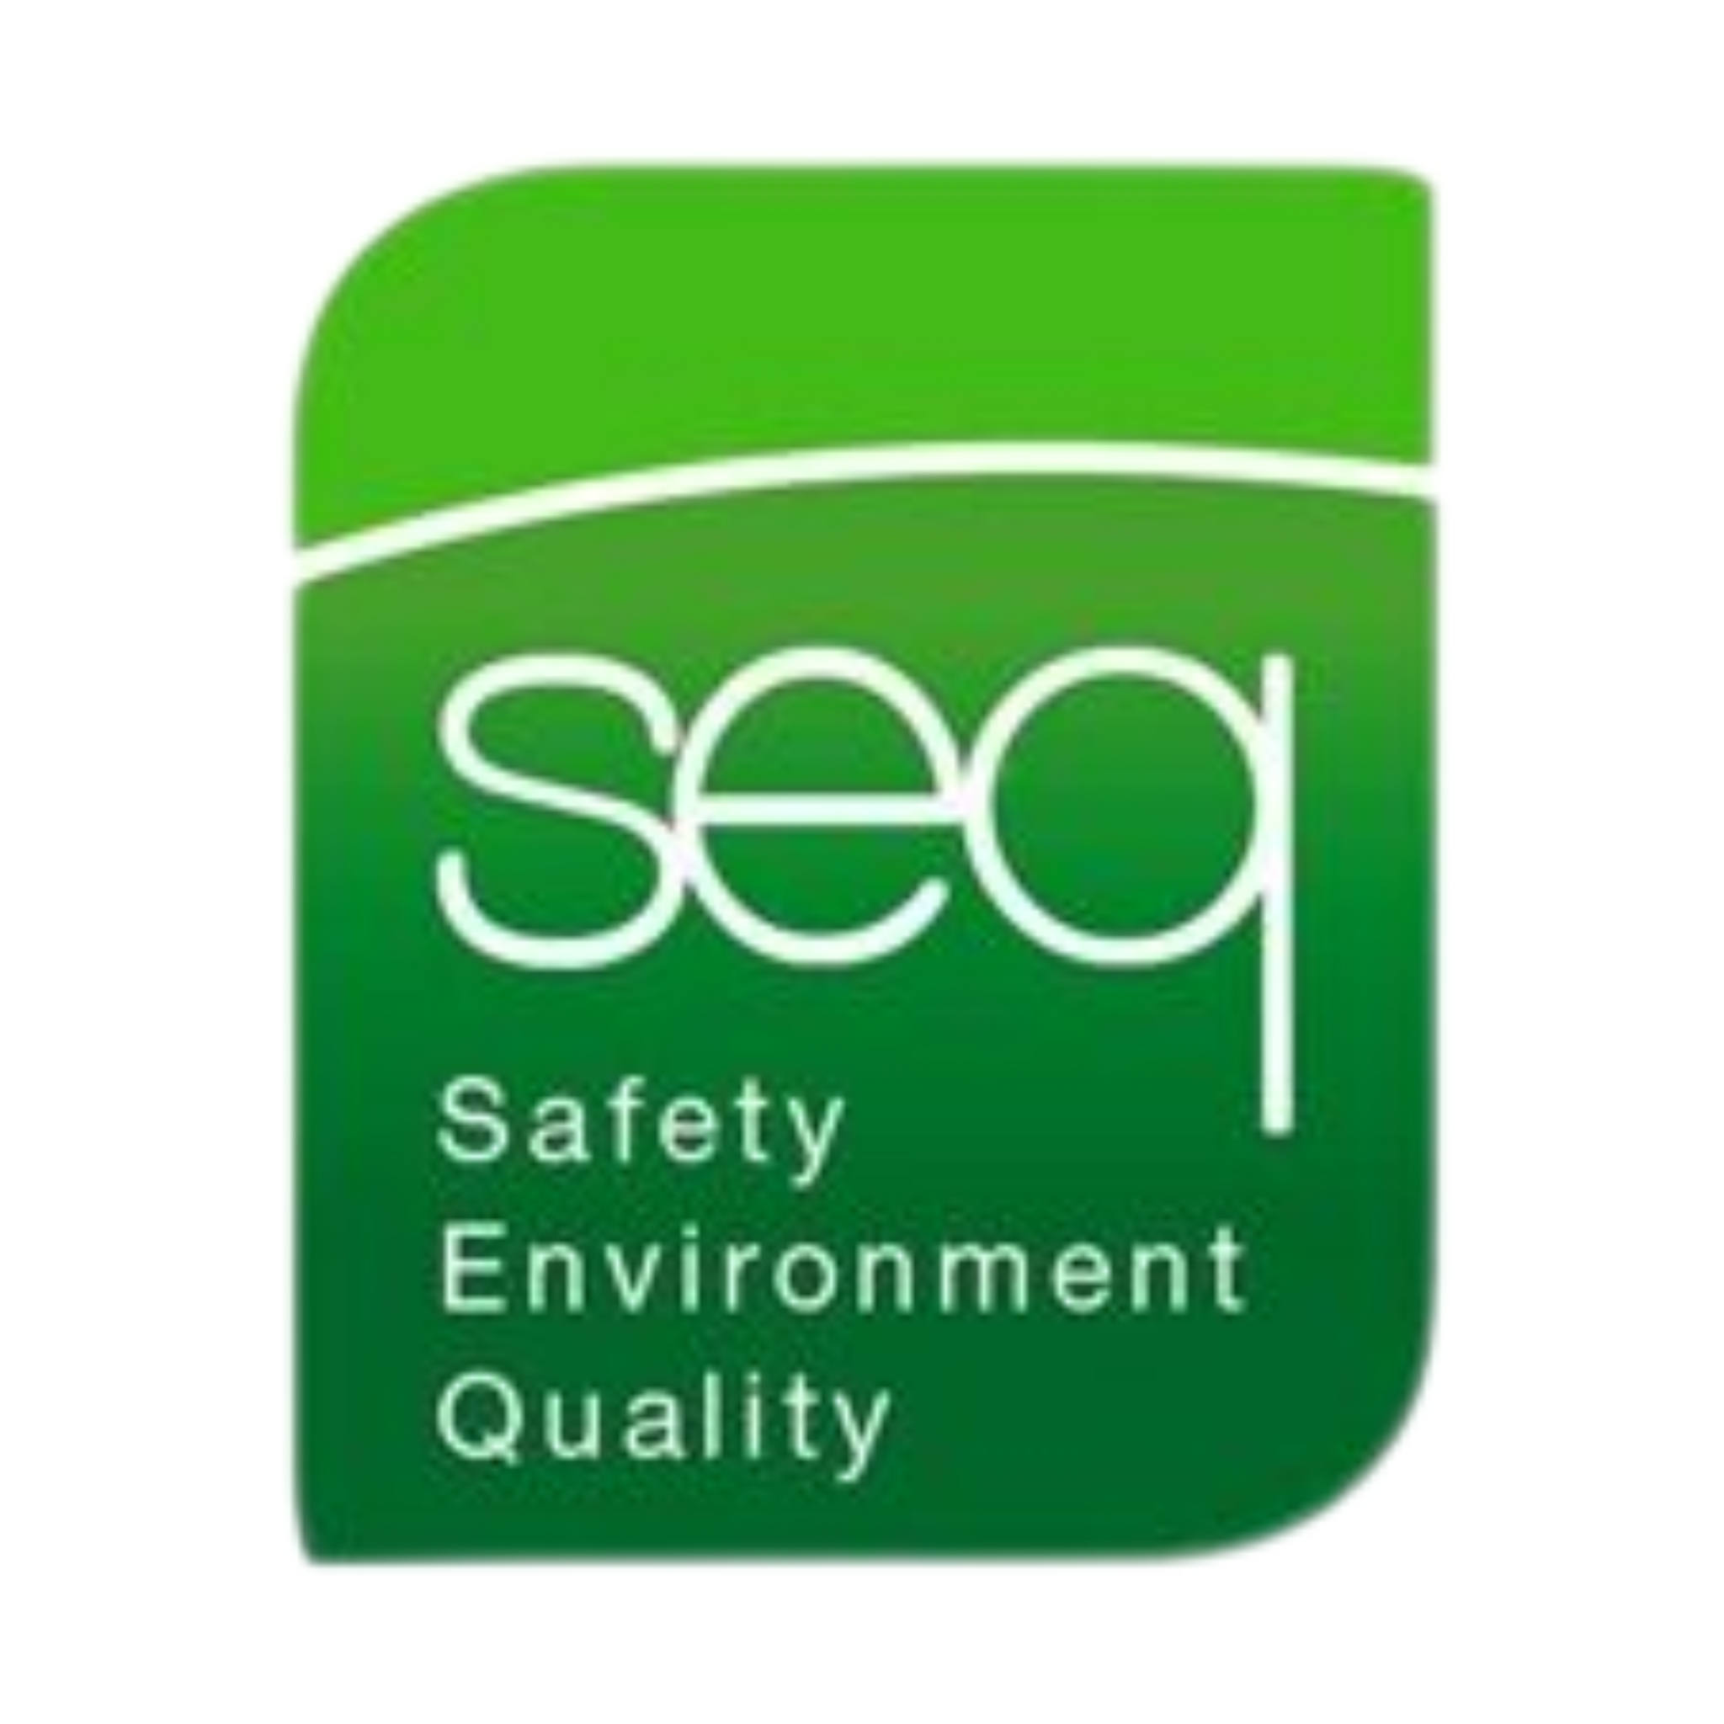 |  | Chemical Safety and spill drill Training
Health & Safety Training to protect  employees and your business.  Contact  PHONE:  01 835 1454  EMAIL:  fergus@seq.ie  WEB:  www.seq.ie  Address:  Unit 11A, Block 4 Ashbourne Business Park Ashbourne Co Meath  Ashbourne Co Meath  A84 W290 |  | Course DETAILS  This half-day course is designed for those who have the potential to be exposed to chemicals in the workplace. Participants will understand the physical and health hazards of chemicals and the importance of the MSDS (Material Safety Data Sheet) to identify methods of protection, emergency procedures and personal protective equipment (PPE).  - Definition of a hazardous substance  - Examples of hazardous substances in the workplace  - Routes of entry into the body for hazardous substances  - The 2007 Code of Practice for the Safety, Health and Welfare at Work (Chemical Agents) Regulations 2001 (S.I. No 619 of 2001)  - Risk Assessment Principles and practice Hazard identification  - Spill Kit Drills – Simulations in a warehouse or stores area  Requirements  Each candidate must have a good knowledge of both written and spoken English.  Details  Duration Half Day  Number of Participants Maximum 10 participants  Certificate Renewal 2 Years

