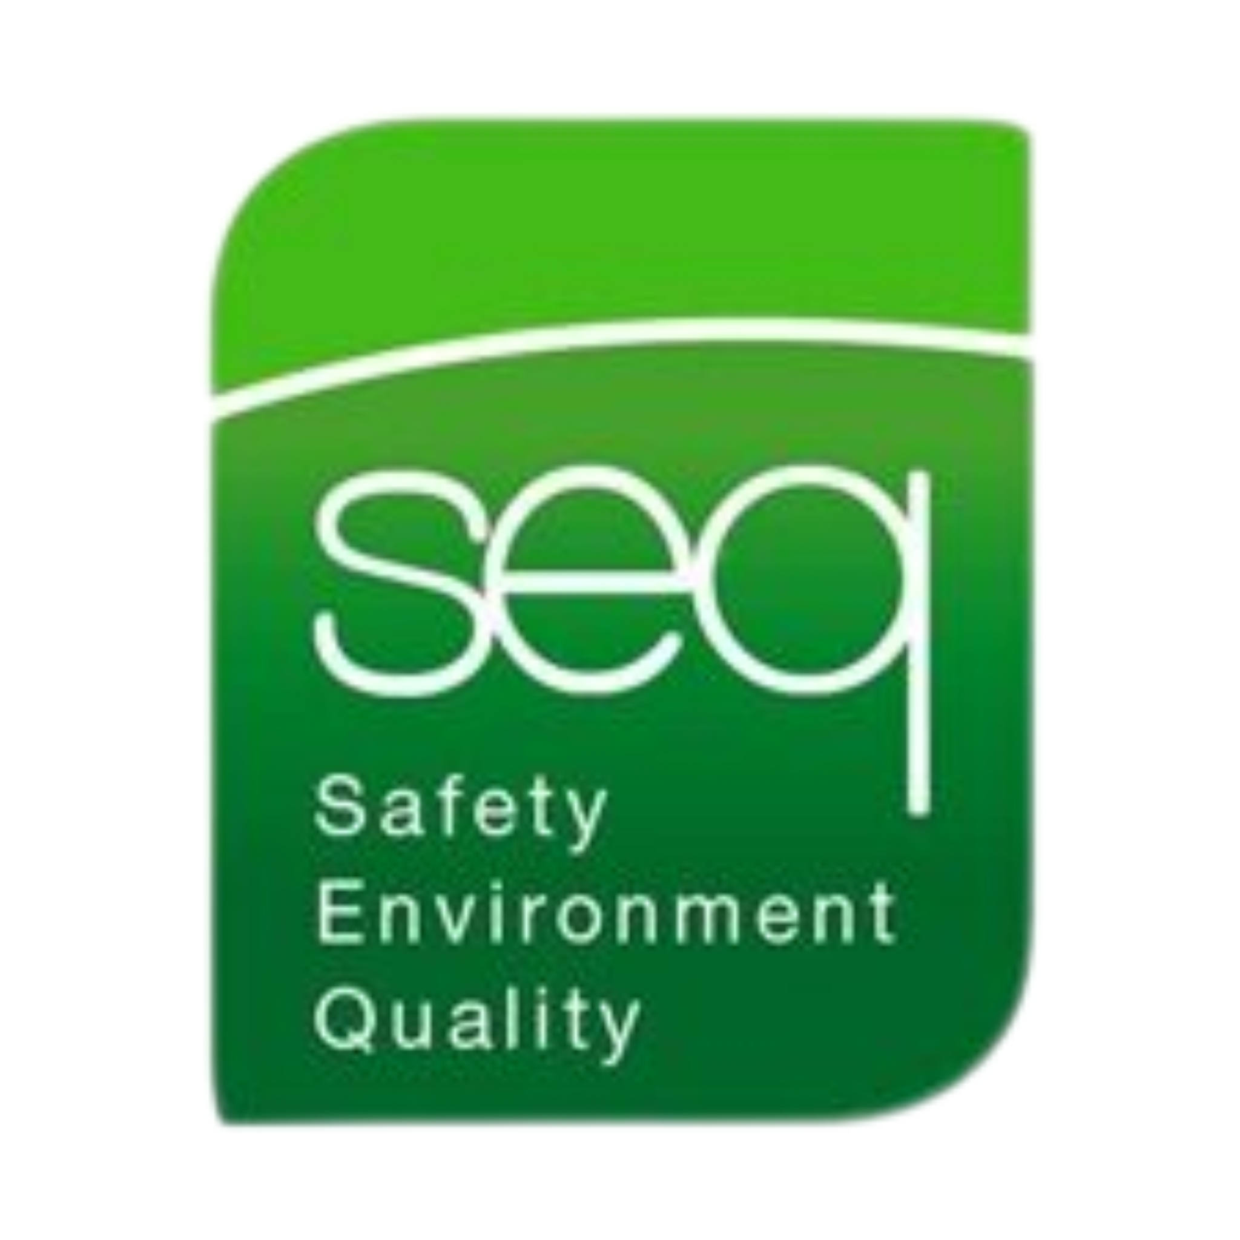 |  | fire WARDEN Training
Health & Safety Training to protect employees and your business.  Contact  PHONE:  01 835 1454  EMAIL:  fergus@seq.ie  WEB:  www.seq.ie  Address:  Unit 11A, Block 4 Ashbourne Business Park Ashbourne Co Meath  A84 W290 |  | Course details  This Fire Warden/Marshall course is designed to raise awareness of fire hazards and how to act safely in the event of an emergency fire situation.  - List the actions to be taken in the event of fire  - Evacuation procedures/site tour/exit points  - Evaluate and (if necessary and not life endangering) fight the fire with the correct extinguisher  - Describe the chemistry of fire  - Fire Safety Legislation (Overview)  - Means of raising the alarm and calling the fire brigade  - Roles of the Fire Warden  - Assessment of the Assembly Area  Requirements  Each candidate must have a good knowledge of both written and spoken English.  Details  Duration Half Day  Number of Participants Maximum 10 participants  Certificate Renewal 3 Years

