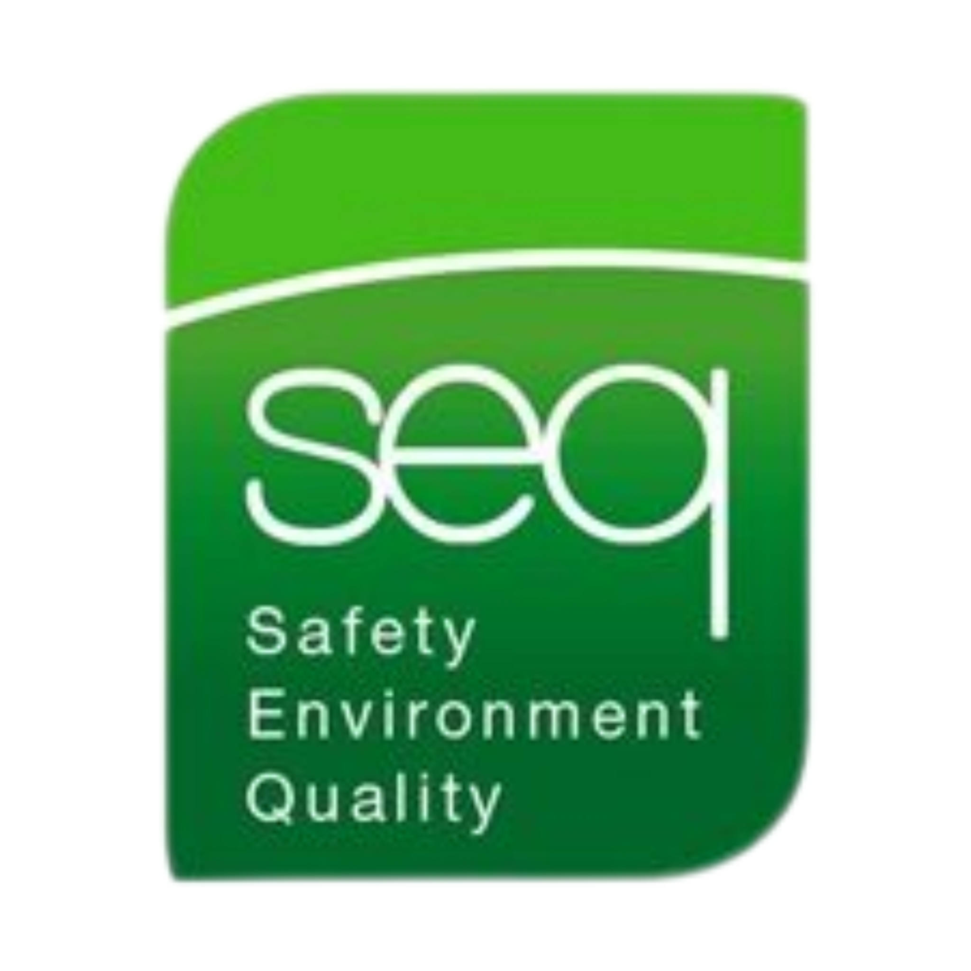 |  | Manual Handling Training
Health & Safety Training to protect employees and your business.  Contact  PHONE:  01 835 1454  EMAIL:  fergus@seq.ie  WEB:  www.seq.ie  Address:  Unit 11A, Block 4 Ashbourne Business Park Ashbourne Co Meath  A84 W290 |  | Course DETAILS  This half-day course is designed to provide the knowledge on how to reduce the risk of injury through correct Manual Handling procedures.  - Understand the limitations of the spine and muscular system  - Recognise a load which is too heavy or awkward  - Lift and handle loads safely and the use of mechanical aids  - Safety Regulations pertaining to Manual Handling in the Workplace  - Importance of physical fitness / use of PPE  - Practice in safe handling of loads and task specific lifts  Requirements  Each candidate must have a good knowledge of both written and spoken English.  Details  Duration 3 Hours Approx  Number of Participants Maximum 12 participants  Certificate Renewal 3 Years

